Project: Todo Web Application
Course: CSD 380 DevOps
Description: Functional test plan based on “Todo Business Requirements” for the Todo application deployed
Date: 2025/11/14
.
TABLE OF CONTENTS
Test 1 - 2 2
Test 2 - 4 3
Test 4 - 5 4

Test 1 | Access the website through the provided URL, and the page will load.
 | Test Objective: Allows the user to visit the website (https://buwebdev.github.io/todo/) | Developer: Kris Kuenning  Date tested: 2025/11/14 | Peer tester: Nardos Gebremedhin  Date tested: 2025/11/14
Step | Action | Expected results: | Developer pass/fail | Tester pass/fail  + Screenshot
1 | Open a web browser | Any web browser you choose to use will run smoothly without encountering network errors or 404 connection errors. | yes | Pass  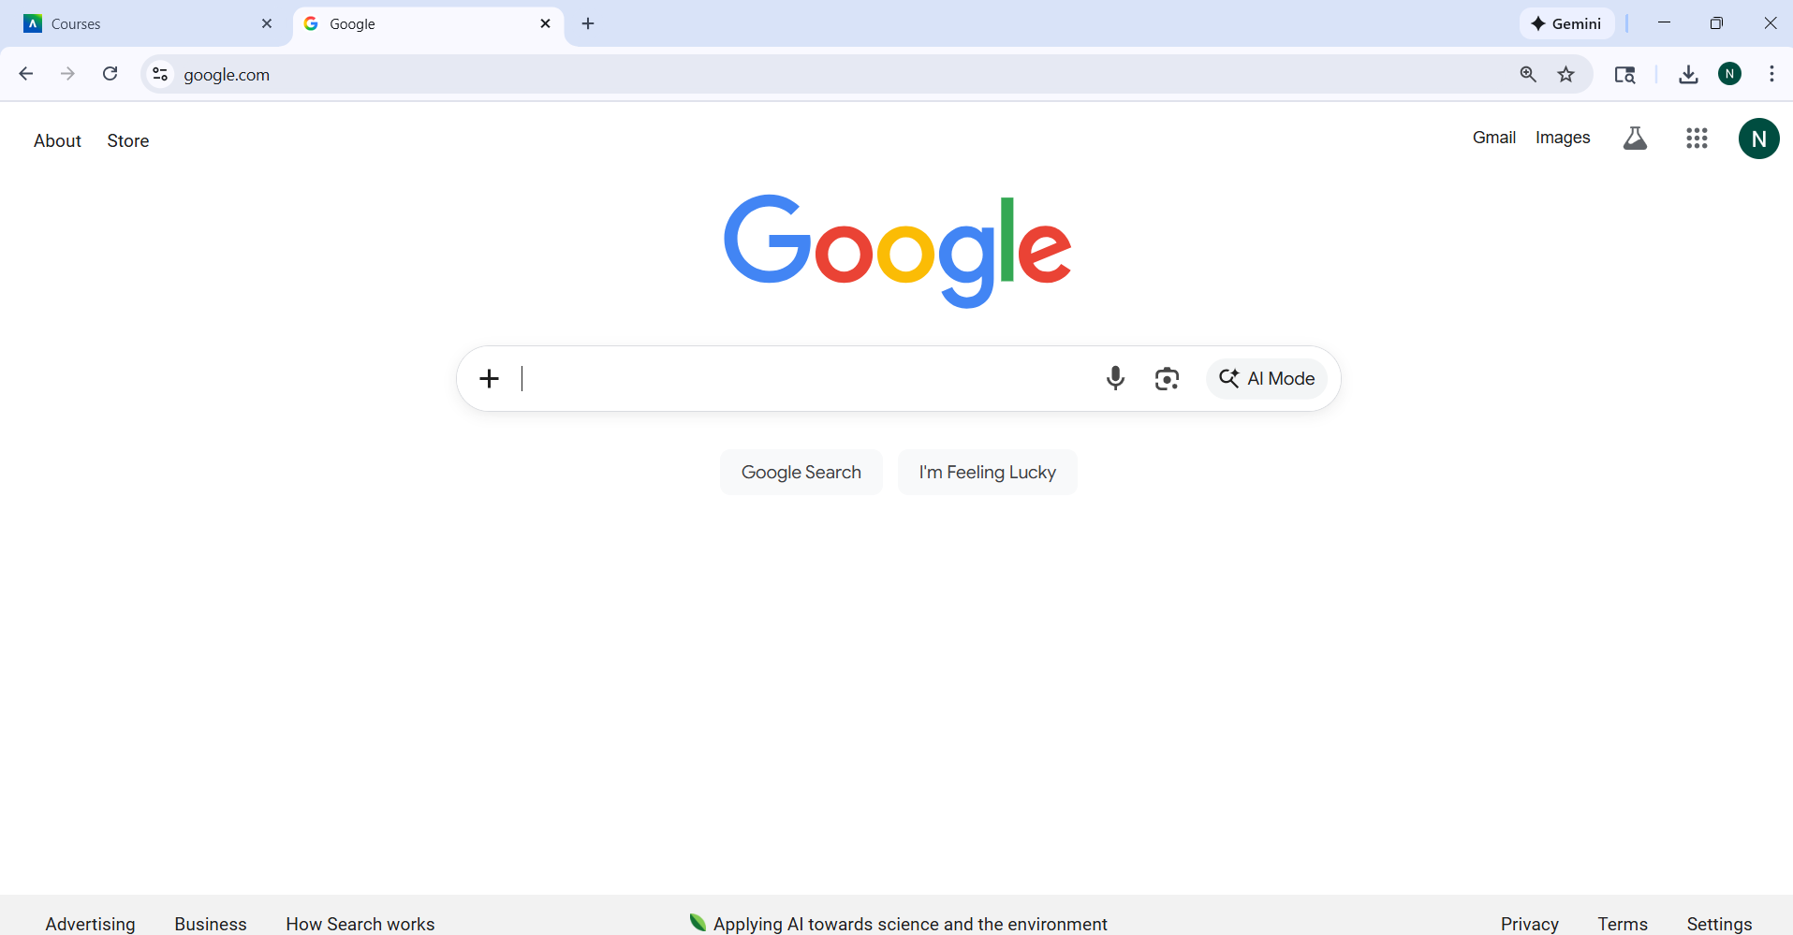
2 | In the address bar, enter https://buwebdev.github.io/todo/ and press Enter. | The ToDo application loads without a network error or 404 connection error. | yes | Pass  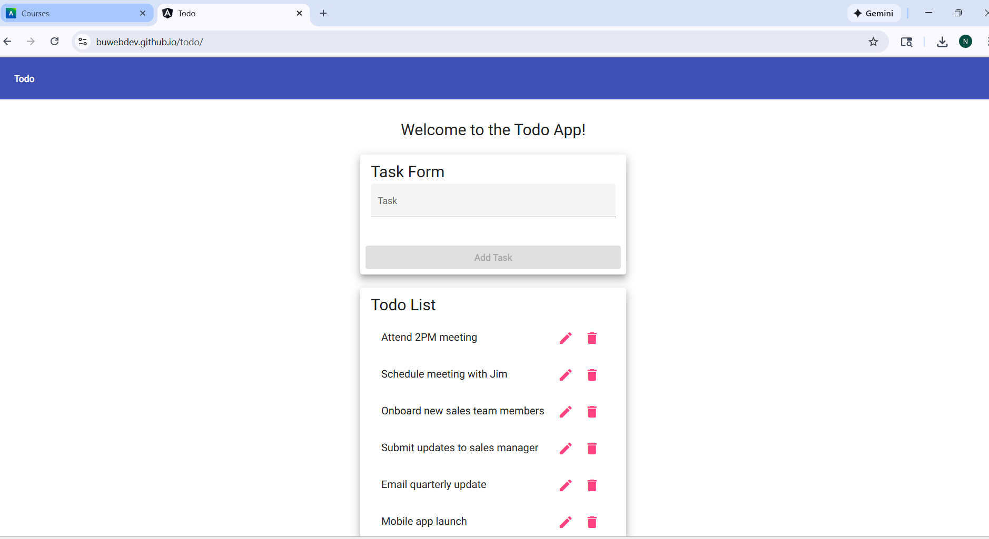
3 | Validate the browser behavior as the page loads. | The ToDo application loads without a network error or 404 connection error. | yes | Pass
4 | Refresh the browser window. | The ToDo application loads without a network error or 404 connection error. | yes | Pass- refreshed without any issue
5 | Close the window and redo steps 1-3 | The ToDo application loads without a network error or 404 connection error. | yes | Pass- opened a new browser and went to the link and refreshed without any issues
Comments

Test 2 | View the list of ToDo task items.
 | Test Objective: View the list of ToDo task items | Developer: Kris Kuenning  Date tested: 2025/11/14 | Peer tester: Nardos Gebremedhin  Date tested: 2025/11/14
Step | Action | Expected results: | Developer pass/fail | Tester pass/fail
1 | Test 1 has passed (site loads successfully) | The site is now open and ready for use. | yes | Pass  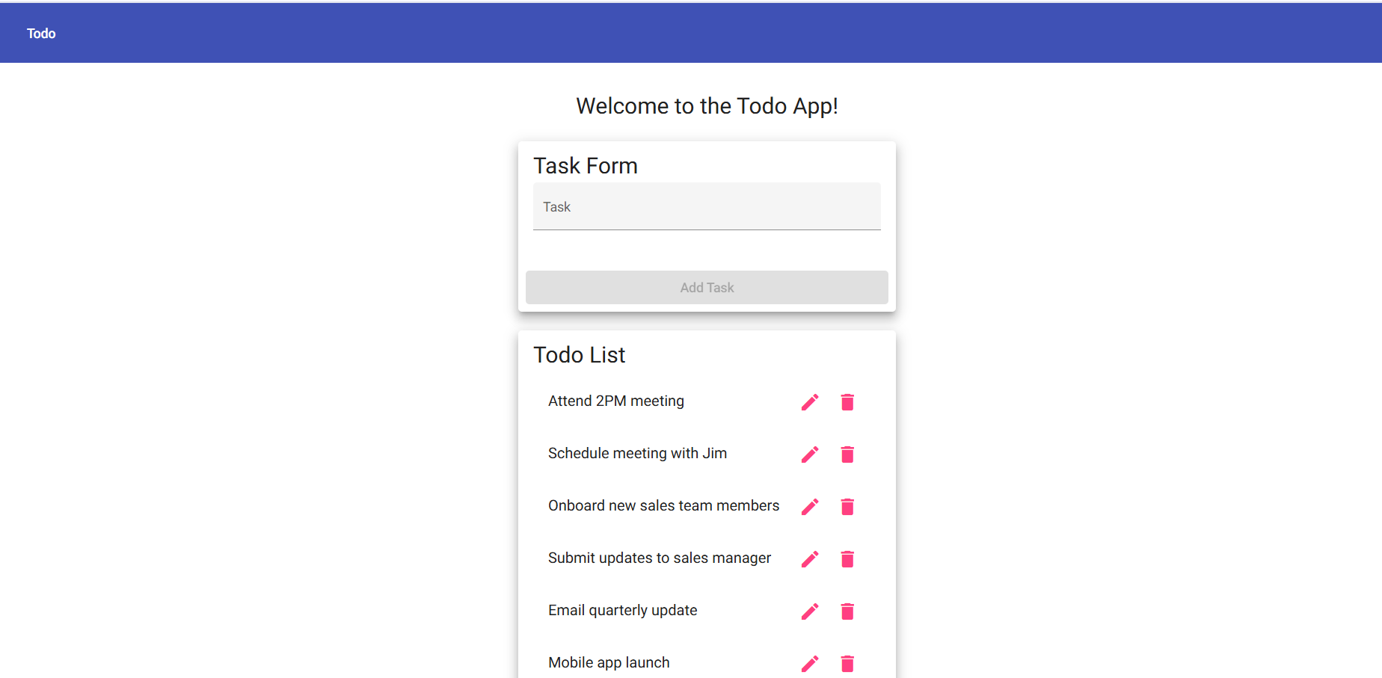
2 | Observe the section of the page where to-do items should display | Each todo item shows | yes | Pass  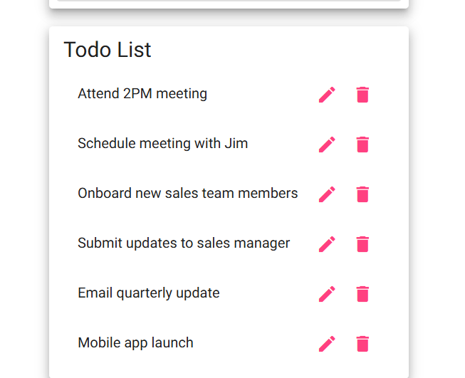
Comments | No JavaScript or rendering errors appear in the console.

Test 3 | Create a new ToDo item & prevent empty submissions.
 | Test Objective: Create a todo item while preventing submission | Developer: Kris Kuenning  Date tested: 2025/11/14 | Peer tester: Nardos Gebremedhin  Date tested: 2025/11/14
Step | Action | Expected results: | Developer pass/fail | Tester pass/fail
1 | Locate the “new todo” input on the main page. | Your cursor should be ready to type a new to-do task in the empty bar. | yes | Pass  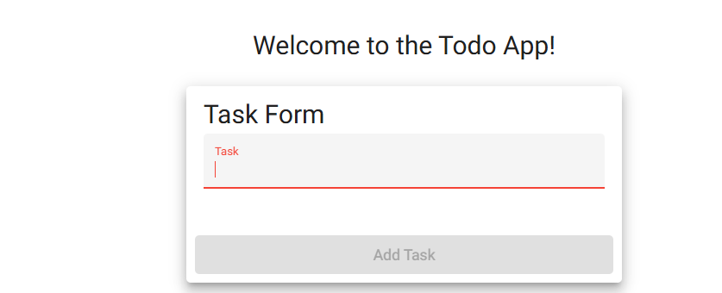
2 | Click into the input field and enter a valid task description | A new task item with the entered description appears in the list. | yes | Pass  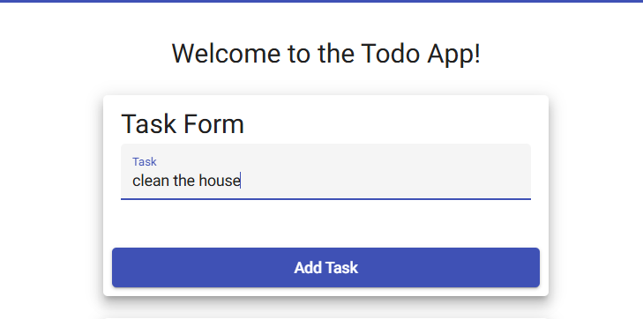
3 | Click the Add/Submit button with the input field. | The new item is displayed in the same format as other items. | yes | Pass  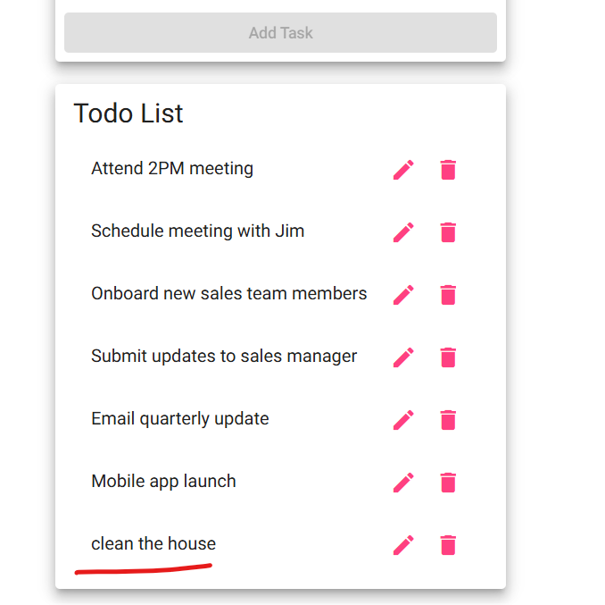
4 | Ensure the “new todo” input field is empty | The system does not create a new todo item. | yes | Pass  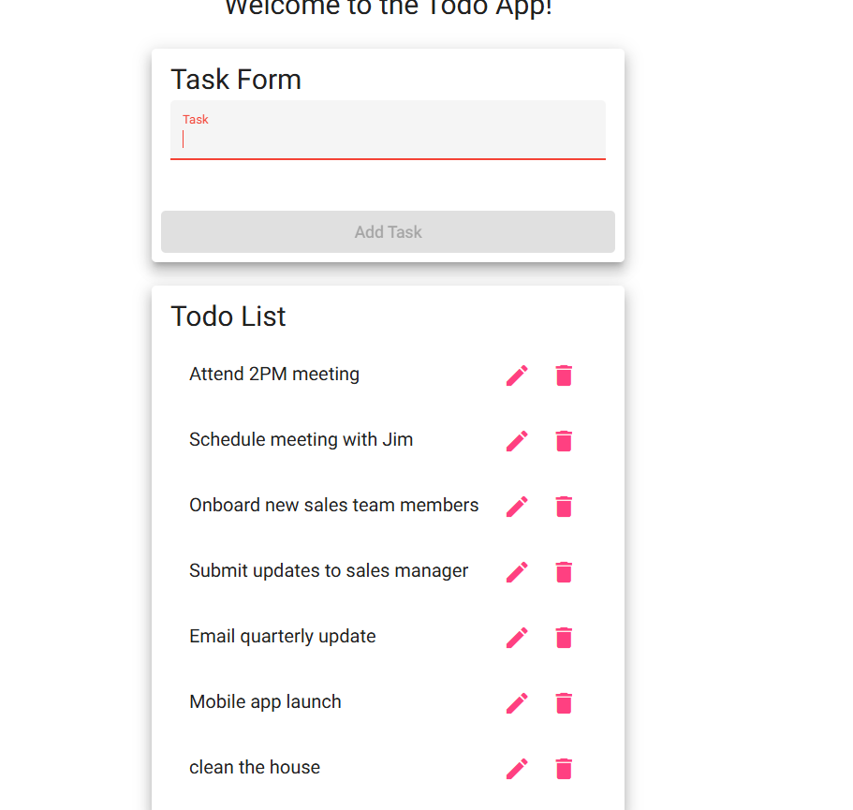
5 | Click the Add/Submit button without entering any text. | The list of todo items remains unchanged. | yes | Pass  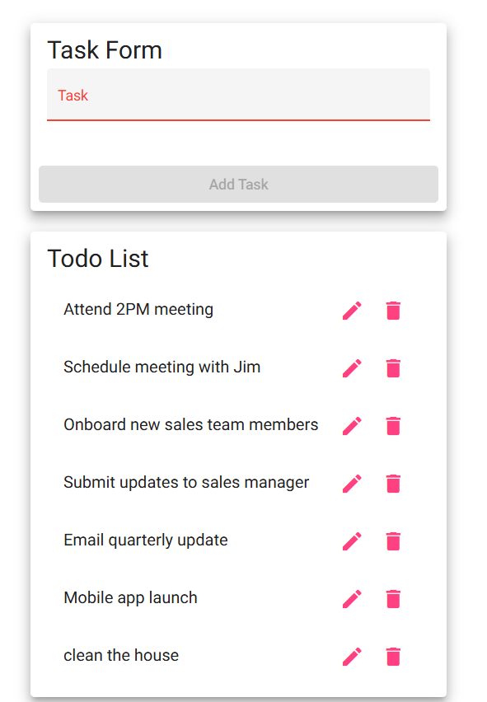
Comments | An alert indicating that a todo item is required should be implemented to provide the user with clear feedback.

Test 4 | Delete an existing ToDo item.
 | Test Objective: Delete a ToDo item | Developer: Kris Kuenning  Date tested: 2025/11/14 | Peer tester: Nardos Gebremedhin  Date tested: 2025/11/14
Step | Action | Expected results: | Developer pass/fail | Tester pass/fail
1 | Identify an existing ToDo item in the list. | Task is checked off. | 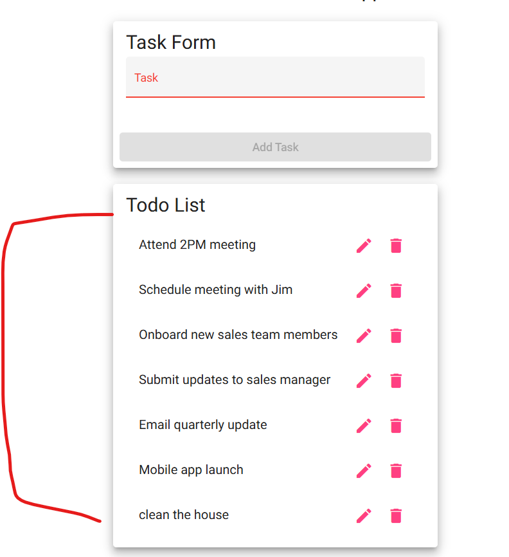 | <yes/no>
2 | Click the Delete control associated with the item. | The selected todo item is removed from the list. | Pass  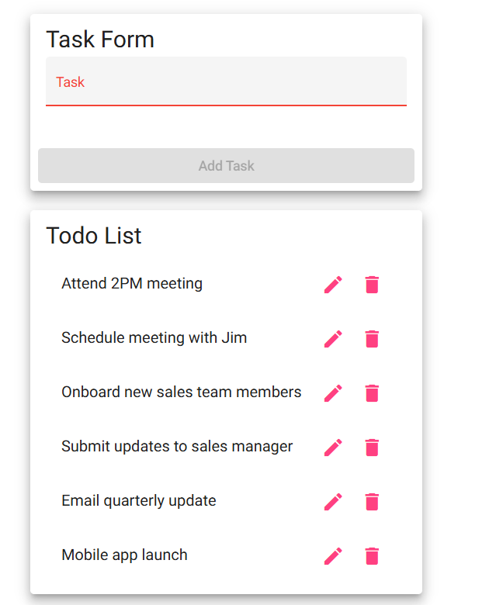 | <yes/no>
Comments | Deleted items do not reappear after refreshing the page.

Test 5 | 404 page for invalid URLs
 | Test Objective: Provide users with a custom 404 error page. | Developer: Kris Kuenning  Date tested: 2025/11/14 | Peer tester: Nardos Gebremedhin  Date tested: 2025/11/14
Step | Action | Expected results: | Developer pass/fail | Tester pass/fail
1 | In the browser of your choice, enter an invalid URL under the ToDo site. Try (https://buwebdev.github.io/todo/nonexistent) | A custom 404 page created by the application is displayed. | yes | Pass  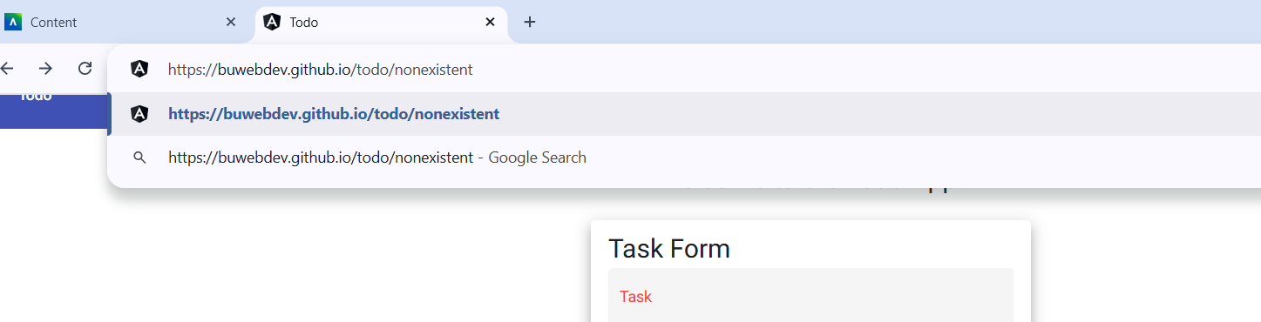
2 | Press Enter and record the page that loads. | The page indicates the requested page was not found. | yes | 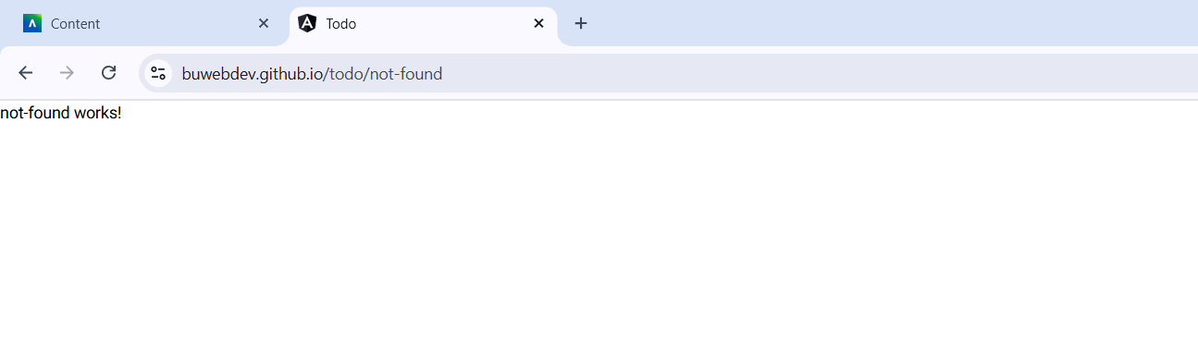
Comments | The page provides a way to navigate back to the main ToDo view via a link or button.

